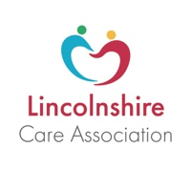

Key messages for July 2020
Social media posts

The world may be opening up for everyone else, but care homes are still working hard to keep COVID from the door. Please bear this in mind when visiting and follow the guidelines that keep staff and your loved ones safe.
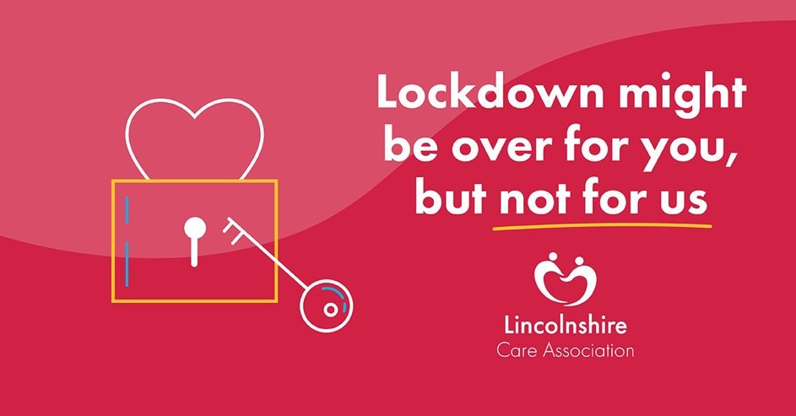

Wearing masks is just one of the ways care home staff are keeping your loved ones safe. So, if you’re asked to wear one when you visit, please do, and join the team in fighting COVID-19.
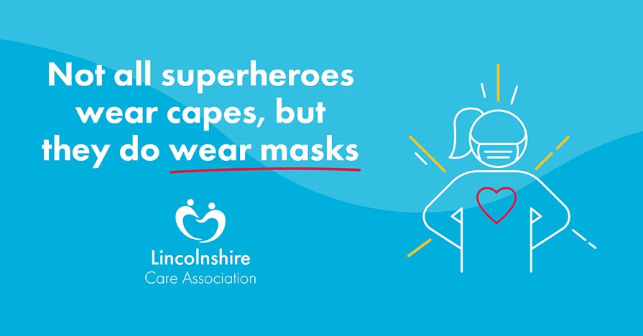

Washing your hands is still the best way to protect your loved ones from COVID-19. So, please remember when visiting a care home resident to wash your hands with soap and water for a minimum of 20 seconds – it’s the first step in keeping them safe.
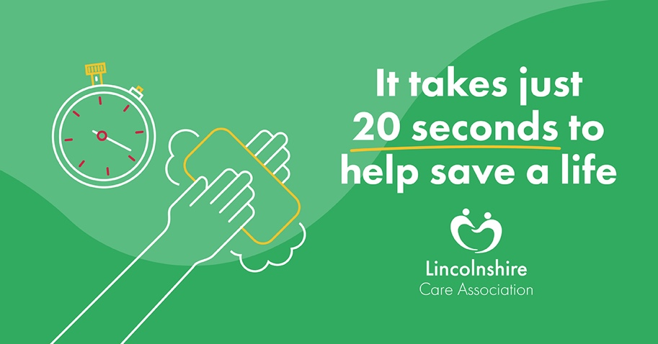

Don’t want to wear a mask? Neither do care home staff, but your loved one’s health must always come first. When visiting, please do the same – we can’t fight COVID-19 without your support.
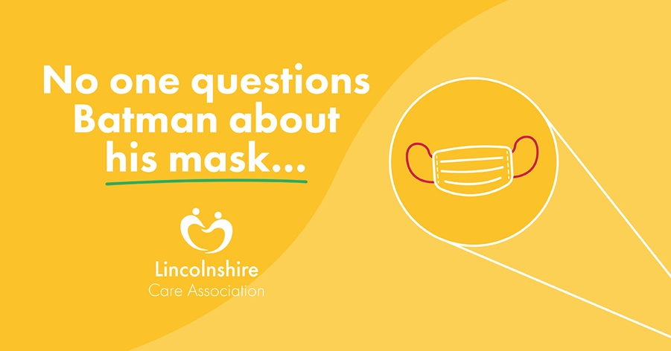

Care homes across Lincolnshire have been conducting risk assessments to find the safest but least restrictive ways to conduct visits. Please follow their guidelines and help keep your loved ones and their friends safe.
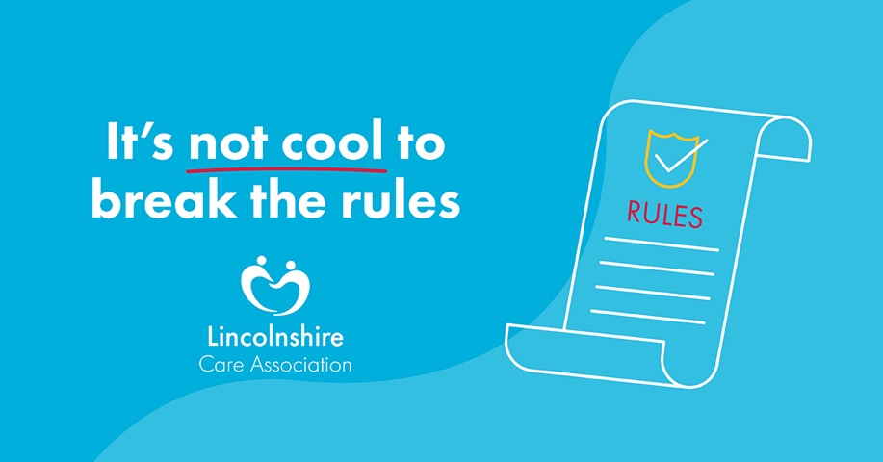

We know it’s hard not being able to give your loved ones a kiss or a cuddle, but social distancing is still necessary to keep the virus from spreading. Help care homes to keep their residents safe and follow the guidelines, your friend or relative will just be happy you came to visit!
