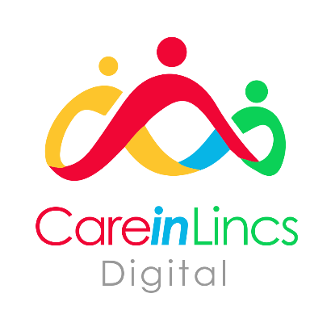
Digital Webinar Booking Form
For the latest available dates, and further information on each of the webinars, please visit our website - LinCA - Digital Webinar Dates

Please indicate which webinar you would like to attend:

Data Security & Protection Toolkit (DSPT)
Introduction to DSPT webinar (1 hour) ☐
Republishing the Toolkit webinar (30 minutes) ☐
Completing the Toolkit webinar (2 hours) ☐

Whzan Telehealth “Blue Box” System
Refresher Training (30 minutes) ☐
Whzan Training, New Users (1 hour) ☐

Please Note:
- All webinars/ training is held virtually, via Microsoft Teams – please ensure the device you are using to access the training has a working camera, microphone, and speaker
- All dates are for Group sessions – multiple providers may be on the call. If you would prefer a 1:1 session, please contact us directly to arrange
- Spaces are limited and allocated on a first come, first served basis

Provider/ Home:
Date of Webinar:
Attendees:
Please ensure names shown are spelt correctly, and where possible provide an email address for the individual
Name and Role:
Email Address:
Name and Role:
Email Address:
Name and Role:
Email Address:

Whzan Training only – Do you know your Whzan login details? Yes ☐ No ☐

Please provide contact details of the person making the booking:

Name and Role:
Email Adress:
Contact Number:

** Please return your completed booking form to – alistair.soons1@nhs.net **

