**Celebrate Professional Care Workers Week with Person Centred Software’s Wellness Activity Pack**

In this pack, you'll find a Mindful Walks Guide, Sensory Spa Recipes, a Sensory Hand Massage Video and a Breathe to Relax Video

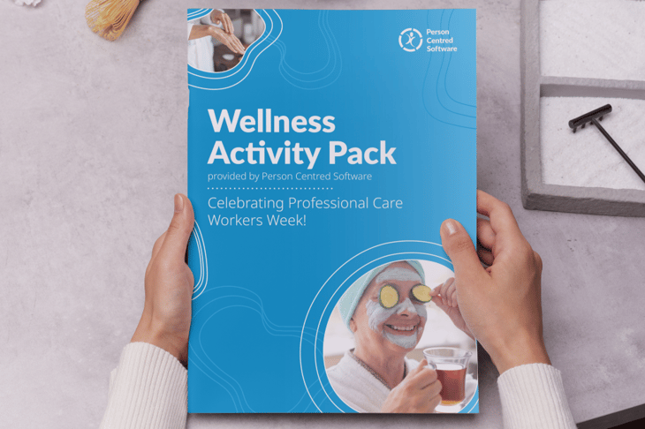

**About this Activity Pack:**

Professional Care Workers Week is an annual celebration dedicated to recognising the incredible contribution of care workers nationwide, as well as promoting awareness and raising the profile of care workers across the UK, from the 16th – 20th of September.

To support this week, Person Centred Software are donating £2 to the Care Workers Charity for every download. By downloading the free pack, you are not only given a set of free activities courtesy of Person Centred Software, but you are also contributing to Professional Care Workers Week!

Download your pack here [https://personcentredsoftware.com/resources/wellness-activity-pack-professional-care-workers-week?utm_source=linca-care&utm_medium=referral&utm_campaign=care-association&utm_content=professional-care-workers-week-24](https://personcentredsoftware.com/resources/wellness-activity-pack-professional-care-workers-week?utm_source=surrey-care&utm_medium=referral&utm_campaign=care-association&utm_content=professional-care-workers-week-24)