Myth 1
Social media image:
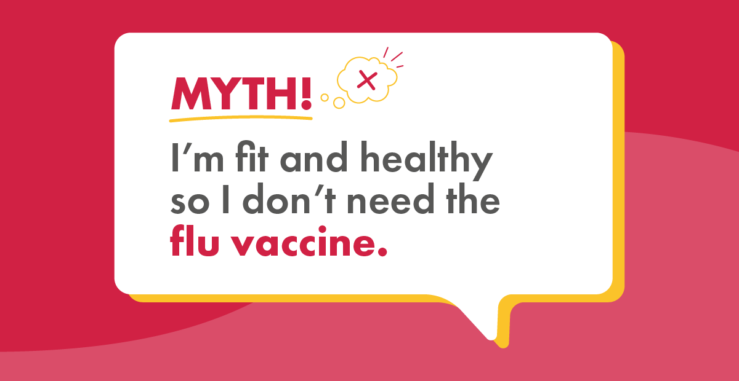

Social media copy:
Fact: You’re fit and healthy, so let’s keep it that way! With 650,000 people worldwide contracting the flu every year, why take the risk? Care workers - visit your local pharmacy to get your free vaccine today!

Myth 2
Social media image:
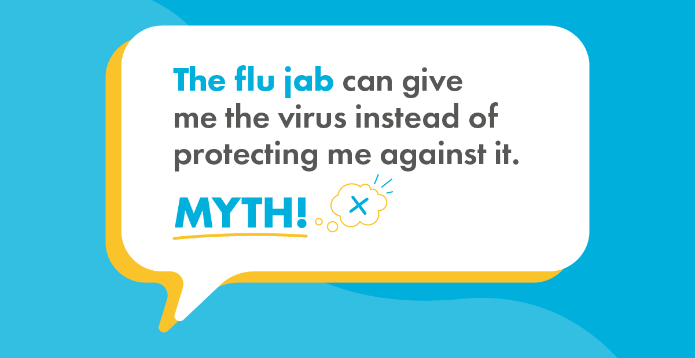
Social media copy:
Fact: The flu vaccine includes a dead or deactivated version of the virus, so won’t make you ill. You may feel feverish or achy for a day or two, but this is just your body getting prepared to fight off any nasties. Carers - visit your local pharmacy to get your free jab!

Myth 3
Social media image:
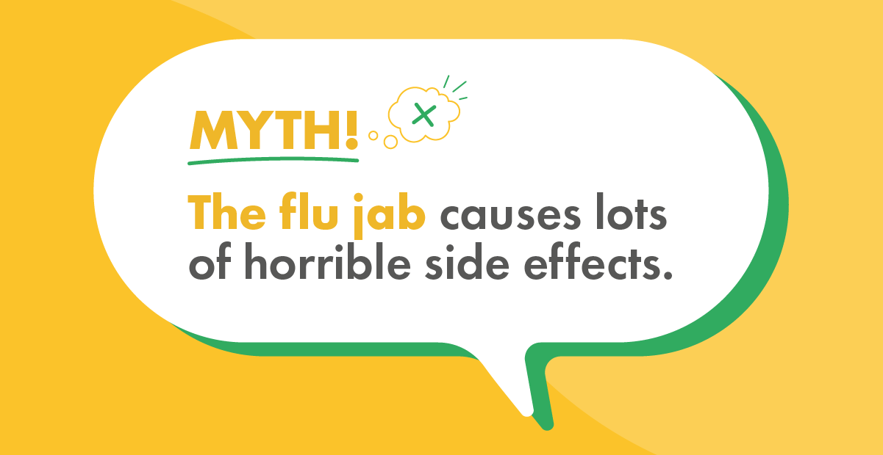
Social media copy:
Fact: The flu vaccine is proven to be safe and has been thoroughly tested before being made available to the public. If you're a care worker, visit your local pharmacy to get your free vaccine!

Myth 4
Social media image:
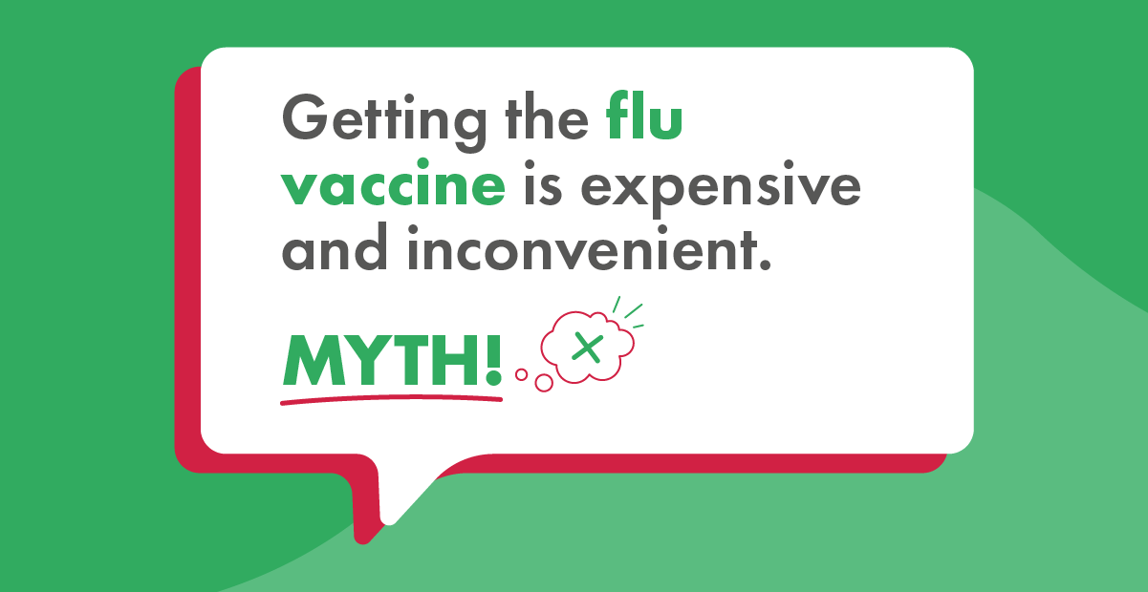
Social media copy:
Fact: Getting the flu vaccine takes only 10 minutes and doesn’t have to be delivered by your GP. Just pop into your local pharmacy for your free shot!

Myth 5
Social media image:
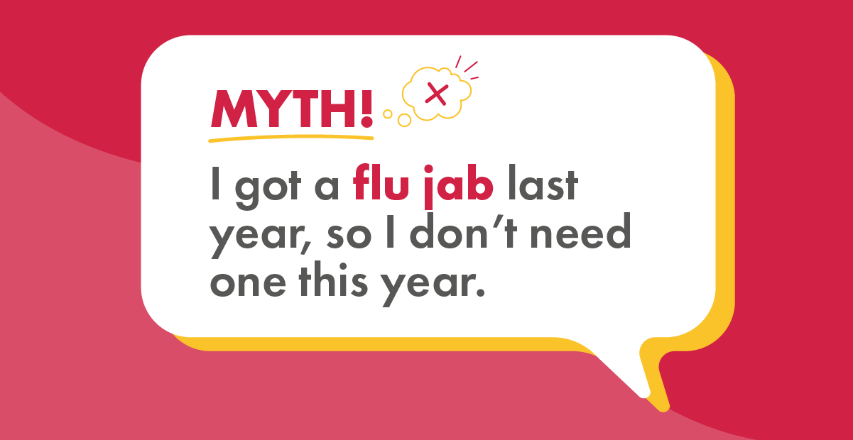
Social media copy:
Fact: As flu strains change so rapidly, you need to get your vaccine every flu season to stop you from getting ill. Visit your local pharmacy to get your free vaccine today!

