I/We wish to apply for Membership of Lincolnshire Care Association and agree to abide by the Terms & Conditions/Constitution of the Association.

By joining LinCA you agree to us sending you member information and data relevant and of value to the wider Lincolnshire social care community. Further details about how we use your information can be found in our company privacy policy.

## Please use BLOCK CAPITALS

NAME OF ORGANISATION REGISTERED WITH CQC (IF APPLICABLE) :……………………………..

……………………………………………………………………………………………………………………….

TYPE OF ORGANISATION:……………………………………………..………………………………………..

NAME OF PROPRIETOR/MANAGER: ……………………………..…………………………………………..

ADDRESS:…………………………………………………..………………………………………………..……..

………………………………………………………………………………………………………………………..

TELEPHONE NO: (Include STD code):……………………...…………………………………………………..

E MAIL ADDRESS:…………….……………………………….…………………………………………………..

ANY ADDITIONAL E MAIL ADDRESSES TO BE INCLUDED ON THE CIRCULATION LIST (I.E. MANAGER, ADMINISTRATOR):

…………………………………………………………………………………………………………………………

NUMBER OF REGISTERED BEDS (CARE HOME ONLY): …………………………………………………

SIGNED: ………………………………………………..…..… DATE:……………………………………..

I/We enclose payment of ***£________*** being calculated at the rate of £5.20 per registered bed (Care Home), or a fee of £300.00 for Domiciliary Care – Lead Providers or £200.00 for other Domiciliary Care Providers, Community Support Services and Extra-Care Housing Care which entitles me/us to Membership of Lincolnshire Care Association for the period ending 31st December 2022***.***

All cheques should be crossed and made payable to “Lincolnshire Care Association.”

BACS Details Account name: Lincolnshire Care Association

Sort Code: 09-01-55

A/C No: 76565180

Bank: Santander Bootle Merseyside GIR 0AA

When completed please return this form together with the appropriate remittance to Susanna Lovelock, Administrator, Lincolnshire Care Association, Greetwell Place, 2 Lime Kiln Way, Greetwell Road, Lincoln, LN2 4US

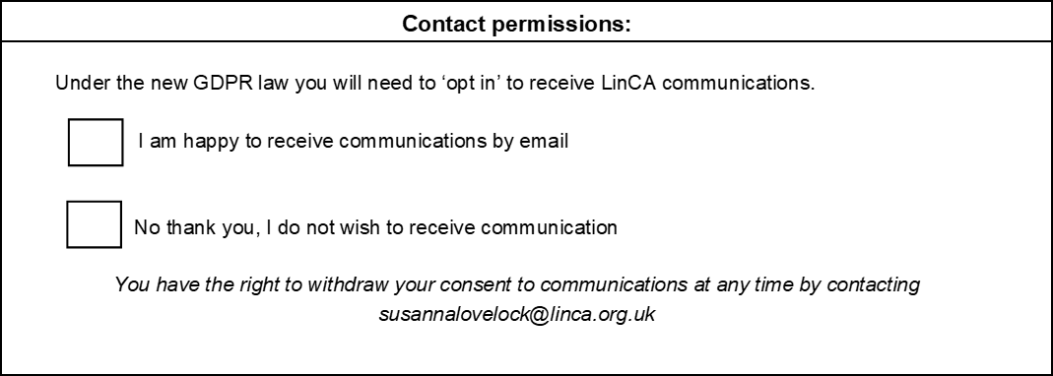

### For Office Use only

Application/Payment Received: 

Website Login/Password Issued:  